**Working with VPNs**

**Setting up VPN:**

1. **Get the extension from Chrome**

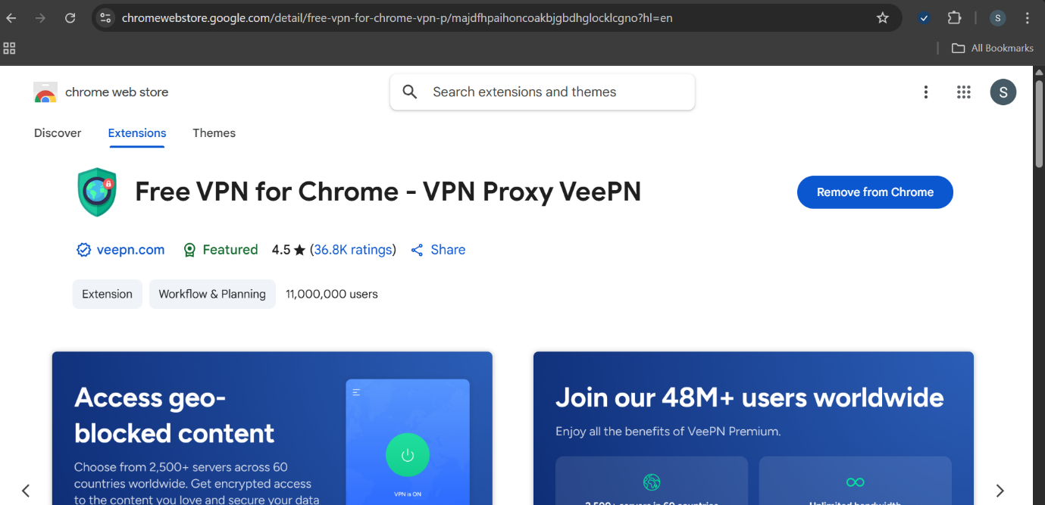

**2.Turn ON the VPN when necessary**

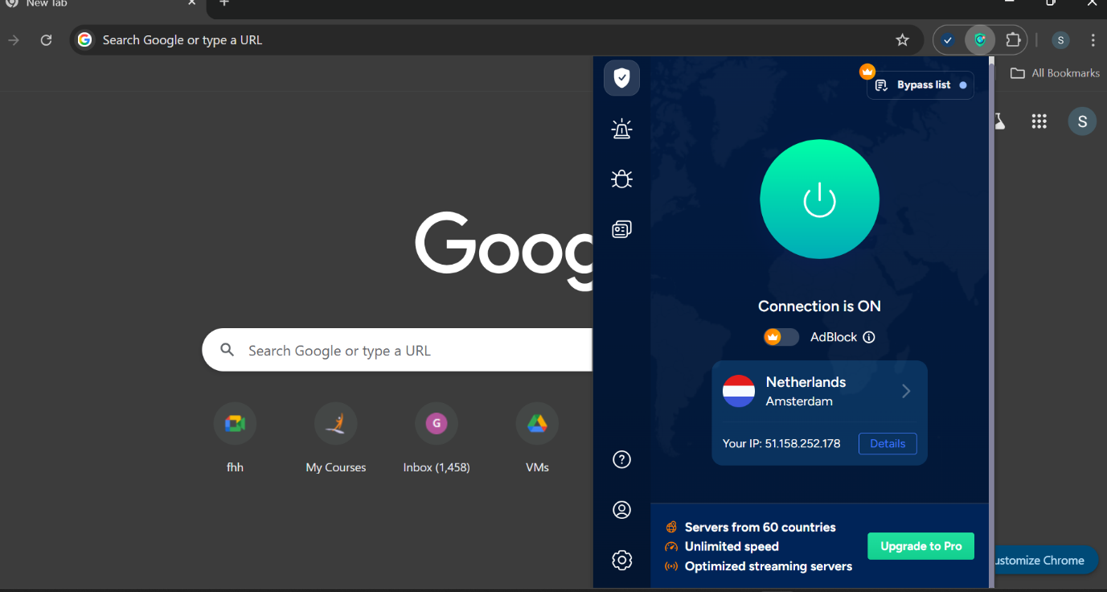

**3.Check the IP Address while using VPN**

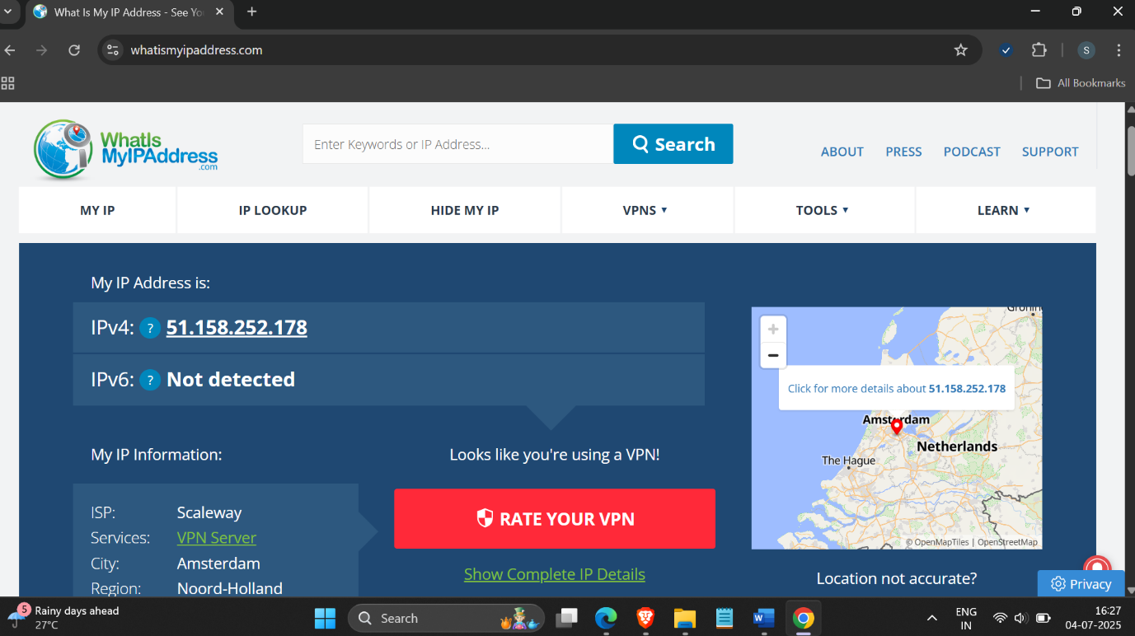

4. Try if connection is encrpyted

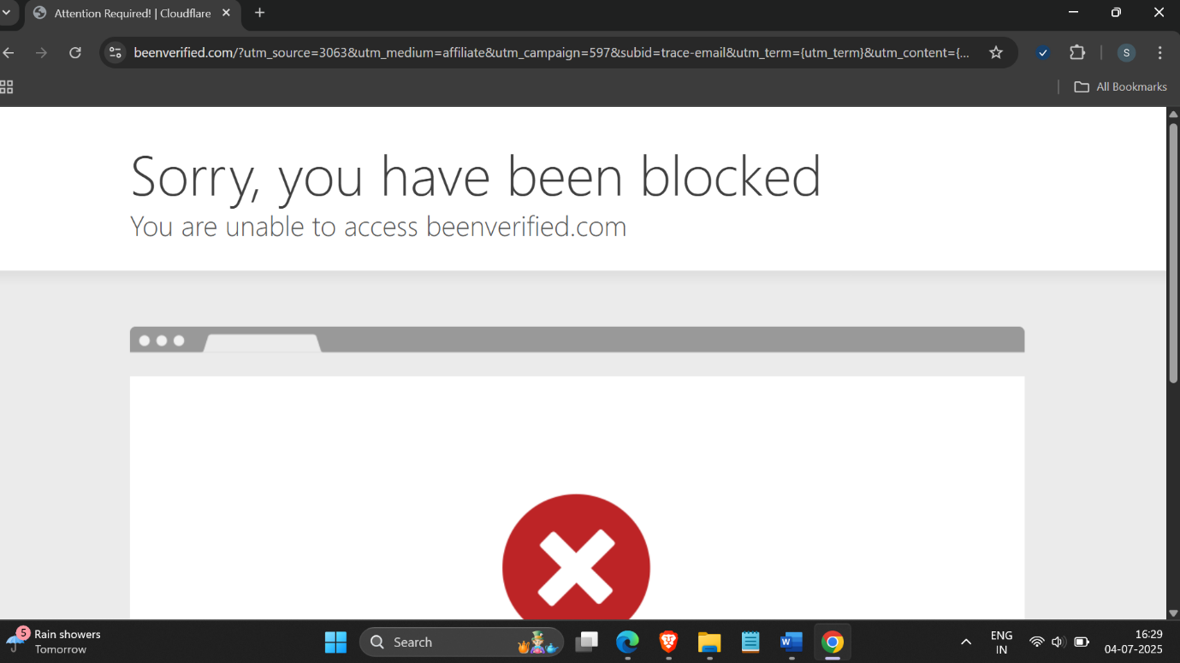

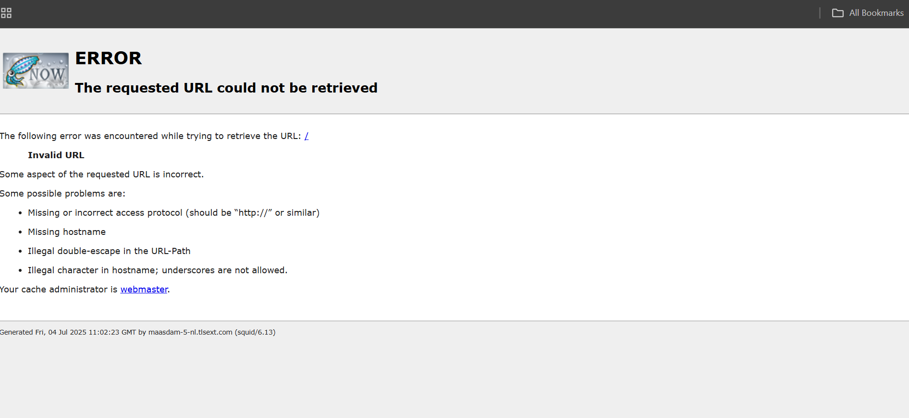

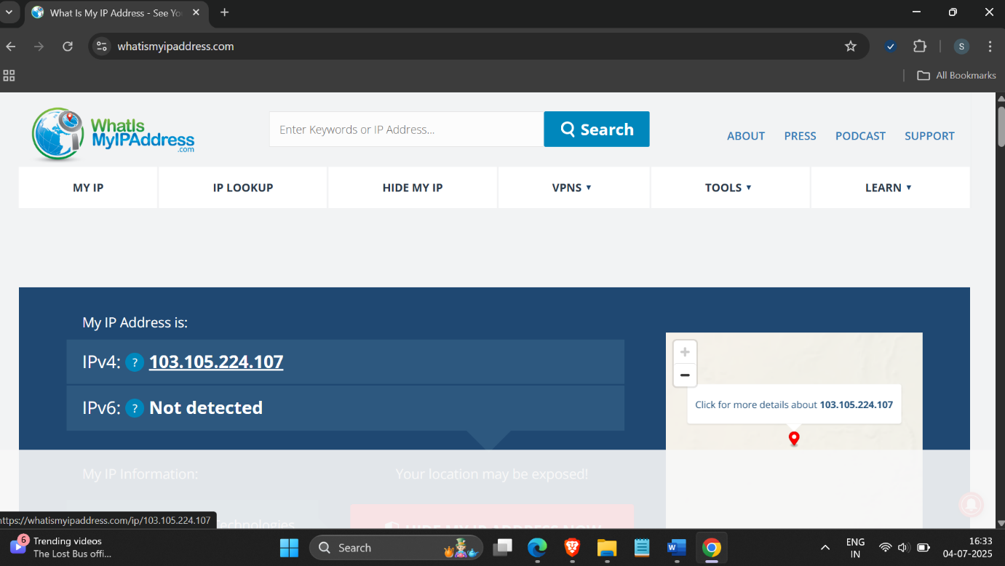

5. Turn OFF the VPN and check the IP again (real IP)

Now u can access all the services

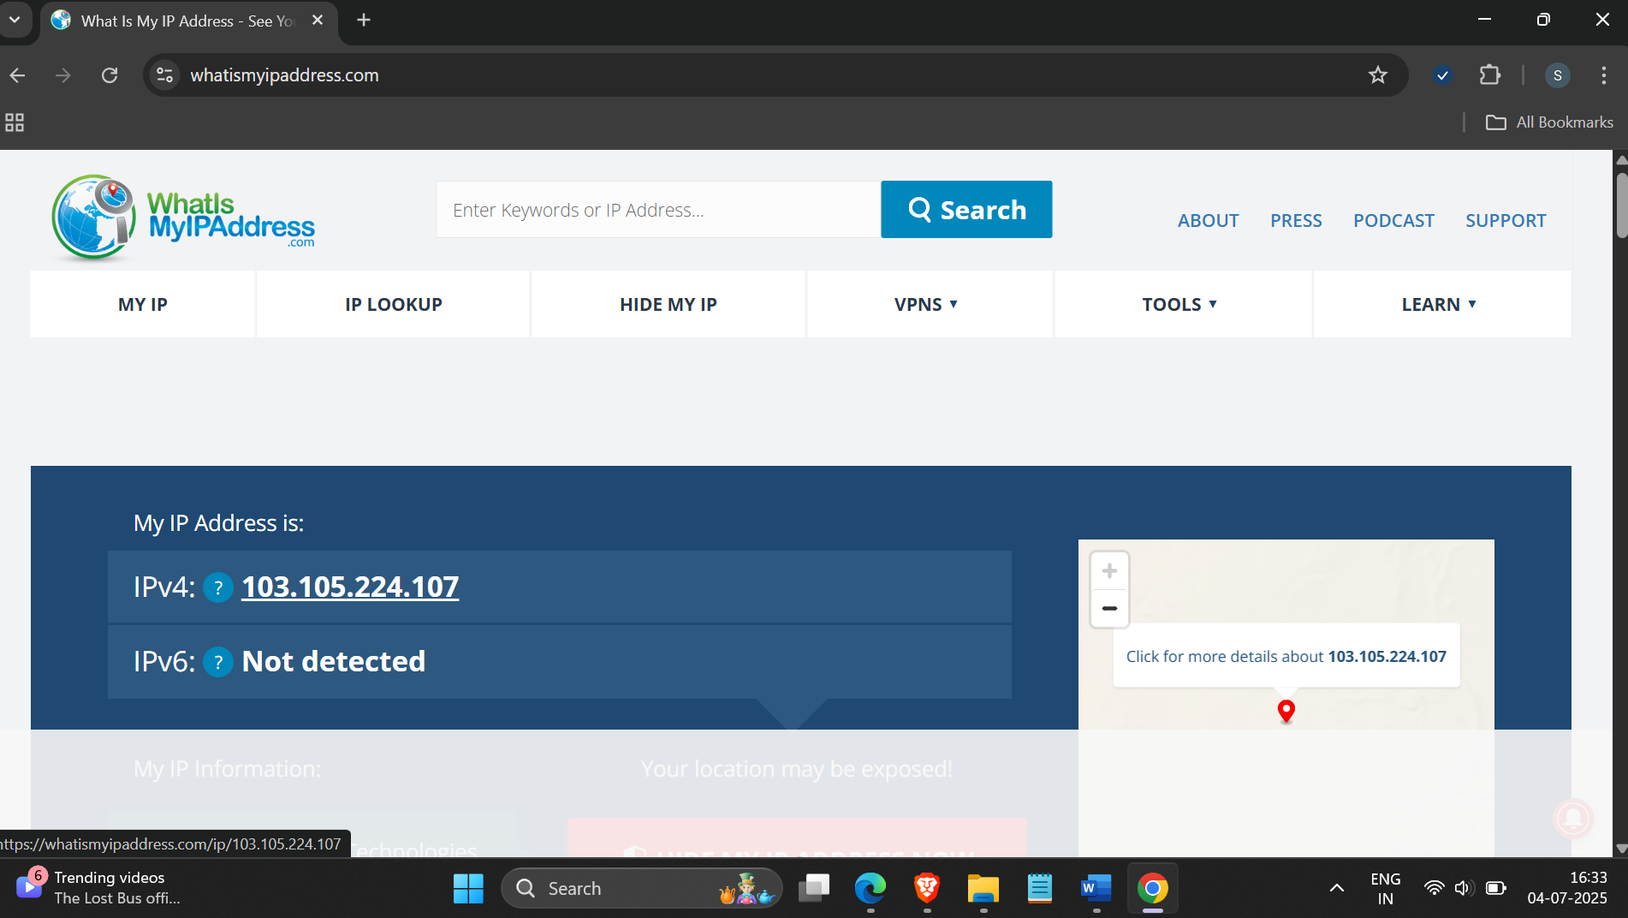

**Summary on VPN benefits and Limitations:**

**Benefits of Using a VPN**

1. Privacy & Anonymity

2. Data Encryption

3. Bypass Geo-Restrictions

4. Security on Public Wi-Fi

5. Avoid ISP Tracking & Throttling

6. Remote Access

**Limitations of VPNs**

1. Does Not Make You 100% Anonymous

2. Trust in VPN Provider

* Your data is protected from ISPs, but not from the VPN itself if it keeps logs

3. Reduced Speed

4. You May Be Blocked

5. Legal & Policy Restrictions

6. No Protection from Malware